The WP2 EurValve Portal is an entry point for the EurValve research environment. The Portal is a user-friendly web application integrated with external services and infrastructures available to the project, such as WebDav file storage or the Prometheus cluster provisioned by the PLGrid e-infrastructure. It simplifies daily duties of EurValve researchers, including file management and sharing or patient case evaluations.
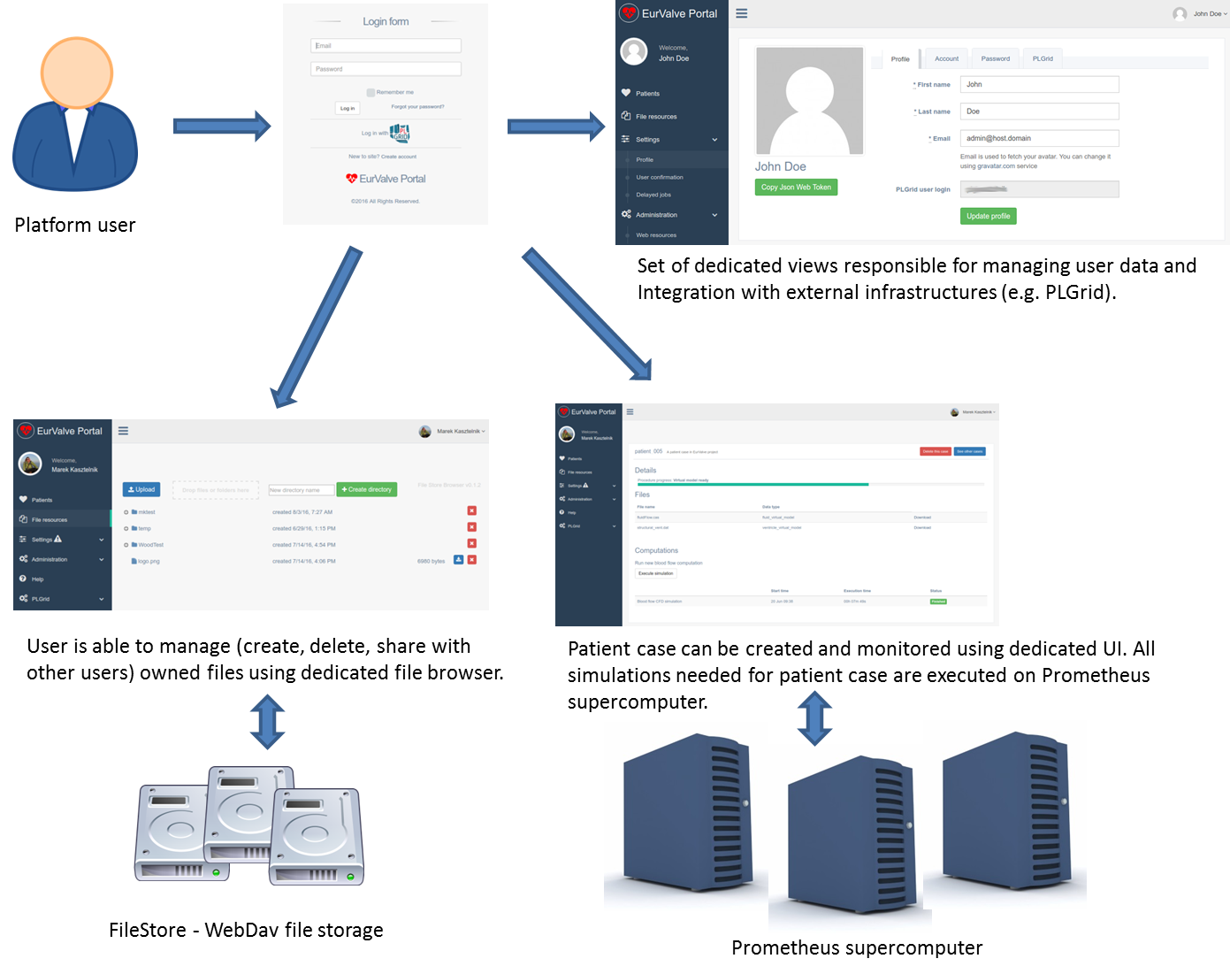
The EurValve Portal is the main entry point for the EurValve research environment, where users can manage the available resources and trigger patient case evaluation.
File Store –binary data management
The first prototype of the file management UI enables users to create/edit/delete folders and files using a convenient web plugin which is built into the Portal. Behind the scenes, the file browser connects to the EurValve File Store WebDAV server using JWT tokens for delegation of user permissions (WebDAV, secured by JWT and integrated with the EurValve Policy Decision Point, is the official EurValve file storage technology).
In subsequent portal releases the file management view will be extended with the ability to share files between users and groups.
PLGrid e-infrastructure (Prometheus cluster)
Patient case evaluation requires CPU/RAM-intensive calculations which cannot be performed on a standalone machine. To solve this problem, the EurValve portal provides the opportunity to execute calculations on the largest Polish supercomputer – Prometheus (CPU 2.4 Pflops, 279 TB RAM) – available as part of the PLGrid e-infrastructure. The initial release of the EurValve portal prototype presents a preview of what this integration looks like. The portal automates file upload to the PLGrid e-infrastructure, executing blood flow simulations and downloading results. Running calculations on the Prometheus supercomputer cuts computation time from several days down to several hours.
In future prototype releases the patient case evaluation workflow will be extended by additional steps contributed by EurValve partners. Additionally, the Portal will be extended with the ability to deploy virtual machines on the PL-Grid e-infrastructure through integration with the Atmosphere cloud platform.
Obtaining access
The EurValve Portal is deployed at https://valve.cyfronet.pl. If you are already a user of the PL-Grid infrastructure and a member of the EurValve PL-Grid group (see https://portal.plgrid.pl), you can log in with your PL-Grid account credentials. Otherwise you will need to obtain a Portal account by using the built-in registration feature. Simply fill in the registration form and wait for one of the Portal administrators to verify and authorize your request.
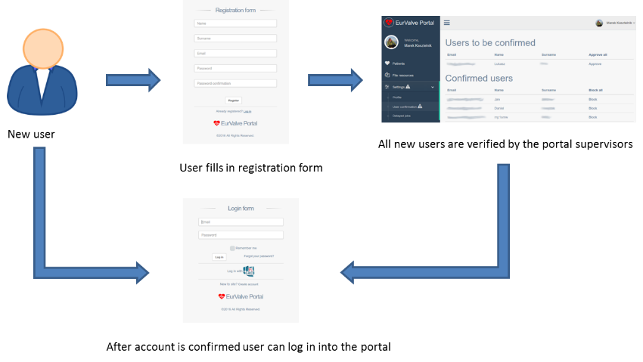
Creating a new user account. Having filled the form at https://valve.cyfronet.pl/users/sign_up the user must be confirmed by a Portal supervisor, following which they will be able to gain access to the EurValve research environment.

