The WP2 EurValve File Store is a remotely accessible service that provides a user overlay for the secure EurValve storage components. It enables users to access, upload and share folders and files pertinent to EurValve. Externally, it mimics a standard WebDAV server and can thus be accessed by any WebDAV-compliant library or by standalone clients. It is also integrated with the EurValve security mechanisms.
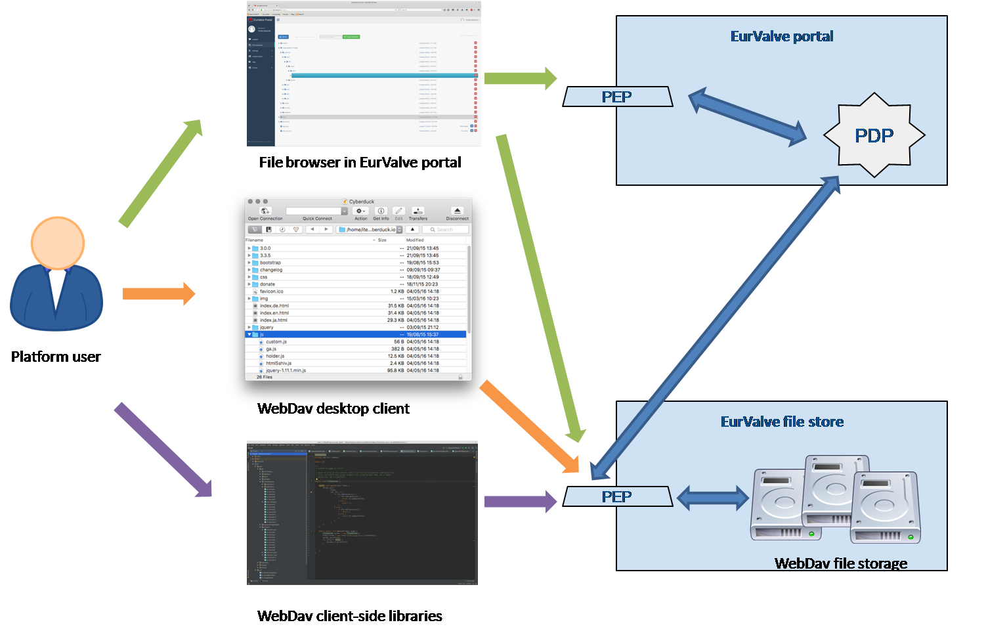
Accessing the EurValve File Store in three different modes (green – through the EurValve portal; orange – through a standalone desktop client; purple – via API calls).
Access methods
A crucial design principle of the EurValve File Store is that it should be easily accessed by end users of the system and by developers working on software packages which interface with the storage components (such as the Decision Support System). Accordingly, the File Store provides several distinct access modes:
- through the File Store Browser embedded in the EurValve portal (requires a web browser),
- through standard off-the-shelf WebDAV desktop clients,
- through a variety of client-side WebDAV libraries for developer access (WebDAV plugins are available for virtually all major programming languages).
Authorization methods
In order to obtain access to the File Store, the user must authenticate themselves and the system must ensure that the client has appropriate access rights for the given data element(s) they’re trying to access. This follows the standard authentication protocol for WebDAV resources – the request must comply with one of the following requirements:
- An authorization token sent with the Authorization header matching the following template: Bearer {token},
- An authorization token sent with the Authorization header matching the following template: Basic base64(bearer:{token}),
- User e-mail and password used to authenticate in the EurValve portal, sent according to the HTTP Basic Authentication scheme.
File Store documentation
The File Store component provides live online documentation – see https://files.valve.cyfronet.pl. The documentation lists the authentication/authorization requirements and provides examples of properly formatted requests.
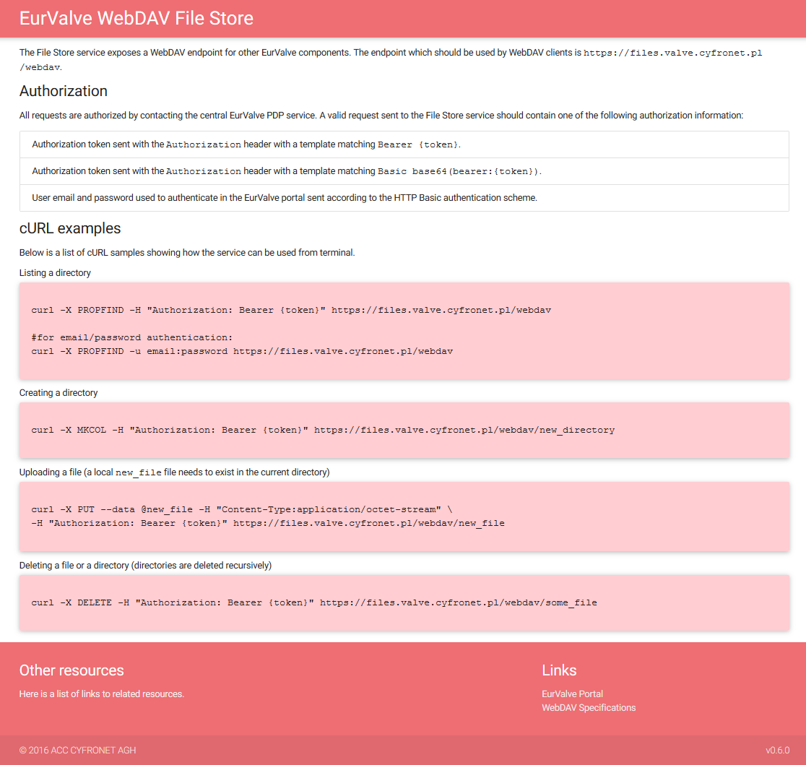
EurValve File Store - documentation page
Accessing the EurValve File Store
As mentioned above, a convenient web-based data browser is integrated with the prototype EurValve portal at https://valve.cyfronet.pl/file_store. This browser can be used to directly access the content of the File Store in a user-friendly way. For programmatic access, a WebDAV API endpoint is provided at https://files.valve.cyfronet.pl/webdav.

